 

**STUDENT REGISTRATION SYSTEM**

An internship Report Submitted to

**DR. VISHWANATH KARAD**

**MIT WORLD PEACE UNIVERSITY**

Submitted by,

**ABHIYANK GOYAL (1032170652)**

Under the supervision of

**Mr. Saurabh Kushwaha**

And

**Prof. Abhishek Chunawaale**

**School of Computer Engineering and Technology (SCET)**

**MIT WORLD PEACE UNIVERSITY, Pune**

**Kothrud, Pune-411038**

**(Period from 5th March 2020 to 29th May 2020)**

1

 

**CERTIFICATE**

This is to certify that the internship Report entitled

**Student Registration System**

Submitted by

**Abhiyank Goyal (1032170652)**

In partial fulfillment of requirement of an internship at Simption Tech. Pvt. Ltd., is a bonafide record of the work carried out by him during the period from 5th March 220 to 29th May 2020. He has worked under the supervision of Mr. Saurabh Kushwaha and Prof. Abhishek Chunawaale. He has fulfilled the requirement of the submission of the internship report for third year Computer Science Engineering as per the syllabus prescribed by the MIT World Peace Univerity, Pune. The material obtained from other sources has been duly acknowledged in the report.

**Mr. Saurabh Kushwaha Prof. Abhishek Chunawaale Prof. Mangesh Bedekar**

(Company Supervisor) (College Supervisor)Head,

School of Computer Engineering and Technology (SCET)

**Date :**

**Place:**

2

**ACKNOWLEDGEMENT**

I wish to express my sincere gratitude to Mr. Devendra Agrawal and Mr. Rahul Agrawal (Directors) of the Simption Tech. Pvt. Ltd. for giving me the opportunity to do internship at their esteemed organization.

I take this opportunity to express my profound gratitude to Mr. Saurabh Kushwaha (supervisor) for his exemplary guidance, monitoring and constant encouragement throughout the course of this internship. The blessing, help and guidance given by him time to time shall carry me a long way in the journey of life on which I am about to embark.

I would like to express my heartfelt gratitude to my co-workers who constantly guided me throughout the internship period.

I also take this opportunity to express a deep sense of gratitude to my college MIT WORLD PEACE UNIVERSITY, Pune (Maharashtra) for organizing this internship where I learnt to work under pressure, and complete the work on the given deadline.

I’m thankful to Mr. Abhishek Chunawaale (College Supervisor) for monitoring my work time to time and giving me helpful suggestions to improve my project.

I would like to thank my parents who always support me with the decision I took in doing my intern. Also I would like to thank my brother for his constant guidance throughout the internship period.

3

**ABSTRACT**

With the advent of Information Technology in the last decade, the major focus has shifted from manual systems to computerised systems. Various systems viz. railway reservation, hospital management etc. involving manual works have been automated efficiently. Student registration processes in Schools/colleges involves filling registration forms manually by administrator, and keep the manual record of each student registered. Also administrator has to keep the separate record manually of the admitted students. As is evident, this process is very laborious and time consuming. An Online student registration system is a web based portal developed in php, HTML5, CSS, JavaScript, AJAX and MySQL. It will allow the online registration of student, and keep the record of the registered students and admitted students. It will also allow the admin to modify student profile, make his/her admission and print fees payment receipt or delete the record the student.

4

**Table of Contents**

**Chapter 1: Introduction**

* Background
* Objectives
* Scope

**Chapter 2: Review of Literature**

* Online registration
* Current registration system
* Proposed registration system
* summary

**Chapter 3: Methodology/Approach**

* Model
* Tools and technologies used
* Variables/Relationships

**Chapter 4: Analysis/Results**

* Output
* Results

**Chapter 5: Interpretations**

**Chapter 6: Conclusions and Recommendations**

**Chapter 7: Suggestions for Future Work**

**Chapter 8: Appendices**

**Bibliography**

5

**Chapter 1: Introduction**

Student online admission is a vital part for any educational organization to be running because students are what keeps an organization alive.Student Registration System will bring a lot of impact to education sector. The education sector needs a robust system. In today’s world most of the work is done manually which consumes lot of time. With the increase in no. of students across the world it is difficult to manage their records manually. This system will help schools/ colleges to maintain the records of the students in a computer which will reduce the manual work of the administer. It will also reduce time to search the record of the specific student. Problem Statement: This part focuses on the challenges faced by the schools/colleges during admission of the student and maintain his/her record. Objective: it focuses on what the current system intends to achieve. Purpose: it provides the feasible solution to the challenges faced.

* 1. **Background**

The current system is a manually operated system where new student is registered manually in a new student register where registration no., student name and other details are recorded. After the student is registered, the person in charge of admission has to count the no. of students manually. All this work is tedious and also wastage of time. In this system the person in charge of the admission will be able to login to the system and able to register new students and can also track information of the student. The school uses manual system in the process of administration and all its data is maintained in the files.

* 1. **Objectives of the Proposed System**

1. Generate unique registration no. for a new student
2. Capture, display and print student details
3. Display all students registered
4. Modify, print, delete and make admission of the student
5. Upload documents required for the students admission
6. Make admission of the student
7. Display all students admitted
8. Modify, delete and print the admission receipt of the student
   1. **Scope**

Without an Online Student Registration System, managing and maintaining the details of the student is a tedious job for any organization. Student online registration system will store all the details of the students like name, class, address, and their parent’s details.

Any student data can be searched quickly rather than wasting time in searching from all the files. This data can be modified or deleted as per the requirements.

6

**Chapter 2: Review of Literature**

**2.1 Online Registration**

An online student registration system streamlines the application, registration, and monitoring of students in a school or training institute. According to Morris Wall (1990), online registration systems are websites that allow users to sign up for memberships, events and training by completing a form. Online registration systems are replacing manual processes, such as registering by telephone, mail or at events using paper forms. Many universities and educational institutions have a wide range of courses, students and faculty (Wells 2001). Registering for classes online reduces paperwork, personnel, cost, and conserves resources. It has been defined by Ralph E. Johnson (1996) as a system where many of you register for courses online. It makes sure that a student can't register for too many courses, and that a course is not oversubscribed.

**2.2 Present student registration system**  
  
in the current system all the activities are done manually. Currently student submits hardcopy of filled application form to the college/university, office staff enters all data into excel file and write same in manual register and issues receipt to student. In the current system we need to keep a number of records related to the student manually. It is very time consuming and costly. In present Student information System, managing and maintaining the details of the student is a tedious job for any organization. This student information management system project is time consuming and has much cost.

**2.3 Proposed student registration system**

In this project, administrator can view and edit the details of any students. Admin can add new users and he can edit and delete a user.

To use the system admin have to login into the system. Admin can enable or disable student account. He can also edit student information in database. He can also search any student in the system by entering his name or username.  
  
Following are the fields that admin can edit form this module.  
  
Student name, Student DOB, Gender, Registration date, Bus service, Hostel, Contact no., City, Parent’s details, Documents.

7

**2.3 Summary**

Good systems, if well implemented, can propel excellence to the next level. Online registration demands the integrity of those in play and the efficiency of the system. The system that is being proposed will fill the gap by providing an actual online registration system which will enable the admin to register student and make his/her admission by entering valid details. More and more, institutions in Zimbabwe are contemplating on the registration aspect component, either exclusively or in conjunction with other registration systems such as traditional paper registration system. The adoption of online support for internet registration systems in any institution would entail a considerable overhaul of traditional registration methods. Students would eventually depart from having many forms of traditional registration methods and data-gathering processes to having just simple methods, delivered by the superior connectivity characteristics of online registration. There is a great need to standardize the method of registration throughout the students at the same institution in order to enhance and streamline the registration process – this is evident by the recent publications of e-registration journals and the academic interest in these areas. Many of the security issues debated involve technically based solutions, currently being developed, to thwart attacks on e-commerce sites. It may be years, or never, before a 100-percent-secure, risk-free internet service, such as online registration, reaches its full potential. But, the same can be said about the numerous registration systems that are currently in place, and for the most part, institutions still conduct their registration and their systems are still relatively stable despite the controversies associated with registration fraud. Registration techniques and its IT infrastructure and combinations present a direct path to online registration, and constitute a logical evolution considering the popular and increasing growth of e-commerce, e-marketing, medical information, e-travel, news, and other web-enabled sources of information online. It is logical that the more educated technology users would want the opportunity to register via the internet. Many students and lectures maintain a web site to communicate their social views and to attract the educated and technologically sophisticated people. According to Bhandari (2004), there are several examples of permanent online registration lists that were developed and are regularly updated through modern technology. It is important to realize the importance of how a new registration system will affect other facets of registration processes, such as access and participation by different groups of student registration, administration and costs. In addition, the sense of saving the cost of the student in travelling to and from the institution just to register would put the credit on the technology we have today.

8

**Chapter 3: Methodology / Approach**

**3.1 Model**

**Used Waterfall Method:**

The Waterfall Model was the first Process Model to be introduced. It is also referred to as a **linear-sequential life cycle model**. It is very simple to understand and use. In a waterfall model, each phase must be completed before the next phase can begin and there is no overlapping in the phases.

The Waterfall model is the earliest SDLC approach that was used for software development.

The waterfall Model illustrates the software development process in a linear sequential flow. This means that any phase in the development process begins only if the previous phase is complete. In this waterfall model, the phases do not overlap.

**Waterfall Model - Design**

Waterfall approach was first SDLC Model to be used widely in Software Engineering to ensure success of the project. In "The Waterfall" approach, the whole process of software development is divided into separate phases. In this Waterfall model, typically, the outcome of one phase acts as the input for the next phase sequentially.

The following illustration is a representation of the different phases of the Waterfall Model.



9

The sequential phases in Waterfall model are −

* **Requirement Gathering and analysis** − All possible requirements of the system to be developed are captured in this phase and documented in a requirement specification document.
* **System Design** − the requirement specifications from first phase are studied in this phase and the system design is prepared. This system design helps in specifying hardware and system requirements and helps in defining the overall system architecture.
* **Implementation** − with inputs from the system design, the system is first developed in small programs called units, which are integrated in the next phase. Each unit is developed and tested for its functionality, which is referred to as Unit Testing.
* **Integration and Testing** − All the units developed in the implementation phase are integrated into a system after testing of each unit. Post integration the entire system is tested for any faults and failures.
* **Deployment of system** − Once the functional and non-functional testing is done; the product is deployed in the customer environment or released into the market.
* **Maintenance** − There are some issues which come up in the client environment. To fix those issues, patches are released. Also to enhance the product some better versions are released. Maintenance is done to deliver these changes in the customer environment.

All these phases are cascaded to each other in which progress is seen as flowing steadily downwards (like a waterfall) through the phases. The next phase is started only after the defined set of goals are achieved for previous phase and it is signed off, so the name "Waterfall Model". In this model, phases do not overlap.

**Tools and technology used:**

The Project is designed with the help of HTML5, CSS, JavaScript, AJAX, PHP, and MySQL.

* **HTML5** is a programming language whose acronym stands for Hyper Text Markup Language. It is a system that allows the modification of the appearance of web pages, as well as making adjustments to their appearance. It also used to structure and present content for the web.
* **CSS** (Cascading Style Sheets) is a style sheet language used for describing the presentation of a document written in a mark-up language like HTML. CSS is a cornerstone technology of the World Wide Web, alongside HTML and JavaScript.
* **JavaScript** is a programming language that is used to describe the behaviour of the web pages. You can use it to add dynamic behaviour, store information, and handle requests and responses on a website.
* **AJAX** is a set of web development techniques using many web technologies on the client side to create asynchronous web applications. With Ajax, web applications can send and retrieve data from a server asynchronously without interfering with the display and behavior of the existing page. It stands for Asynchronous JavaScript And XML.

10

* **PHP (Hypertext Pre-processor)** is a programming language that allows web developers to create dynamic content that interacts with databases. PHP is basically used for developing web based software applications. This tutorial helps you to build your base with PHP.
* **MySQL** is an open-source relational database management system. MySQL is one of the best RDBMS being used for developing various web-based software applications.
* **XAMPP** is a free and open-source cross-platform web server solution stack package developed by Apache Friends, consisting mainly of the Apache HTTP Server, MariaDB database, and interpreters for scripts written in the PHP and Perl programming languages.

**Variables/Relationships:**

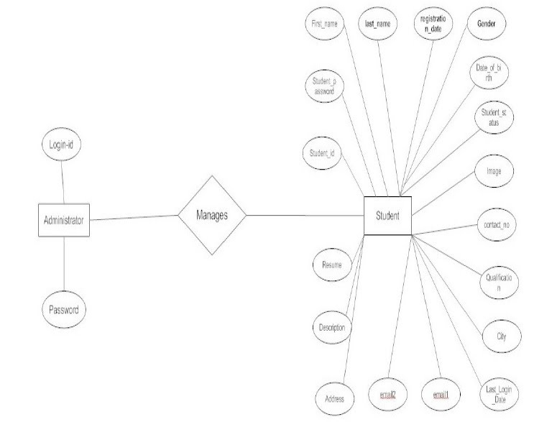

11

**This project consists of different modules:**

**Login Module:** In this module the admin can Log in to the admin panel with the help of username and password. After entering the details on the login page, the details will be validated with the database and upon successful validation, admin will be directed to the admin panel where he can register a new student or see the already registered students list or admitted students list.

**Sign-up module:** Inthis module new admin can be created by the organization.

**Registration Form:** when the admin will be logged in successfully, he will be directed to the page where new student can be registered by filling the details of the student such as name, class, contact number, registration fees, DOB, date of admission, parents details, etc. and on click of the submit button the student will be stored in the database.

**Registered Students List:** the admin can see the list of all the students (fetched from the database with the help of php and MySQL) already registered where he can modify, make admission or delete the record of the student.

* On click of the modify button the admin will be directed to a new page where the student details will be displayed (fetched from the database) and can be modified as per the requirements.
* On click of the make admission button the admin will be directed to a new page where the student details will be displayed (fetched from the database) and documents can be uploaded as required for the admission. Also here the admin can also modify the student details.
* On click of the delete button the student record will be deleted from the database and the list will be loaded again.

**Documents upload:** Variousdocuments like Aadhaar, date of birth, or other valid document

of the students and his/her parents or guardians can be uploaded. On upload of the documents, the folder will be created with the registration number of the students where all the documents related to the student will be stored.

**Admitted students list:** the admin can see the list of all the students already admitted where he can modify, print receipt of the admission or delete the record of the student.

* On click of the modify button the admin will be directed to a page where the student details will be displayed (fetched from the database) and can be modified as per the requirements.
* On click of the delete button the student record will be deleted from the database and the list will be loaded again.
* On click of the print button the receipt will be printed of the admission of the student which can be handed to the student/parents.

12

**Chapter 4: Analysis / Results**

After analysis the requirements we decide that we need to create following web pages

* Sign Up Page
* Login Page
* Registration Page
* Page to display all registered students
* Edit profile page
* Make admission page where documents can be uploaded
* Page to display all admitted students

**1)** **Sign-Up Page**



In this page a new admin can be assigned by the organization and a username and password can be given to the administrator to login to the application.

13

**1) Login Page**

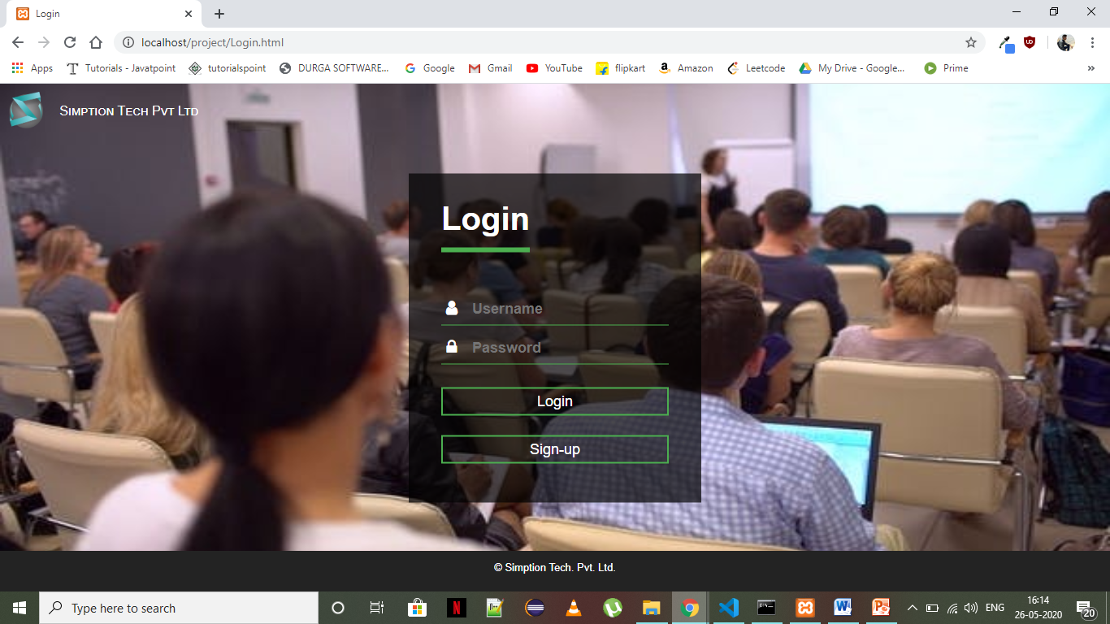

On this page an admin can Login to the application by entering his username and password as given by the organization.

**2) Registration Page**

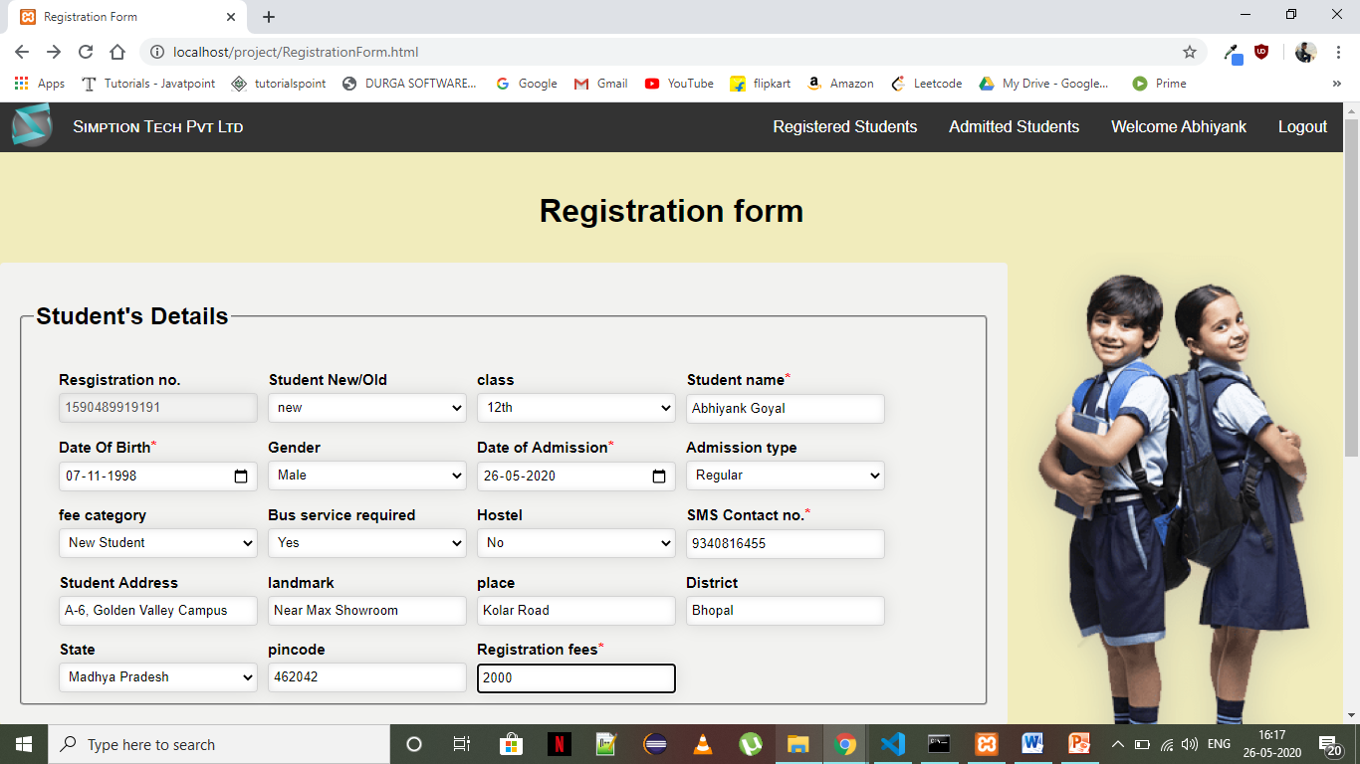 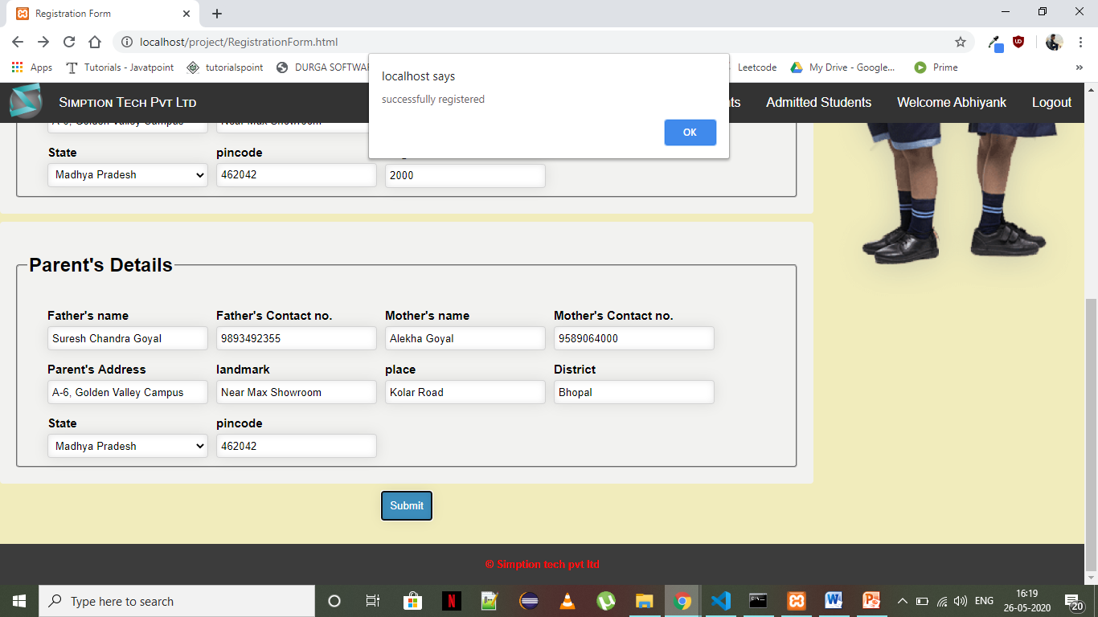

14

On this page the admin name is displayed in the navigation bar. Here the admin can navigate to the registered students page and admitted students page. Admin can enter the details of the new student to register the student. On successful registration the data will be stored in the database.

**4. Registered students page**

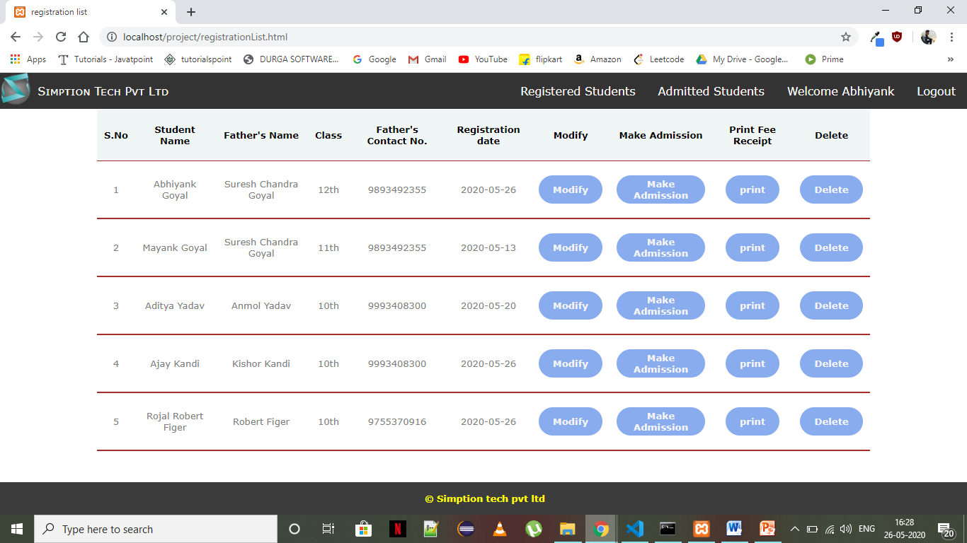

Here the admin can see the list of all the students already registered and can search any student quickly which saves the time and headache of the admin to go through the files.

Also he can modify the details of the registered student or delete the record of the student and also has an option to print the receipt of the registration fees. He can click on the make admission button to make the admission of the student.

**5. Page to update details of the student**

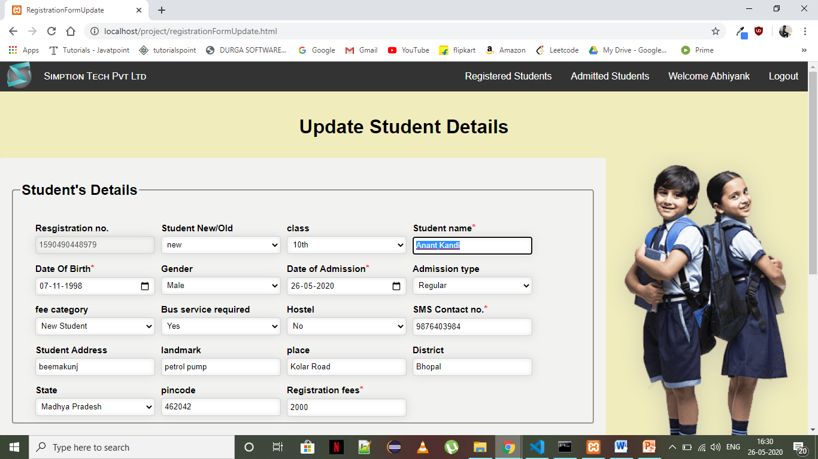

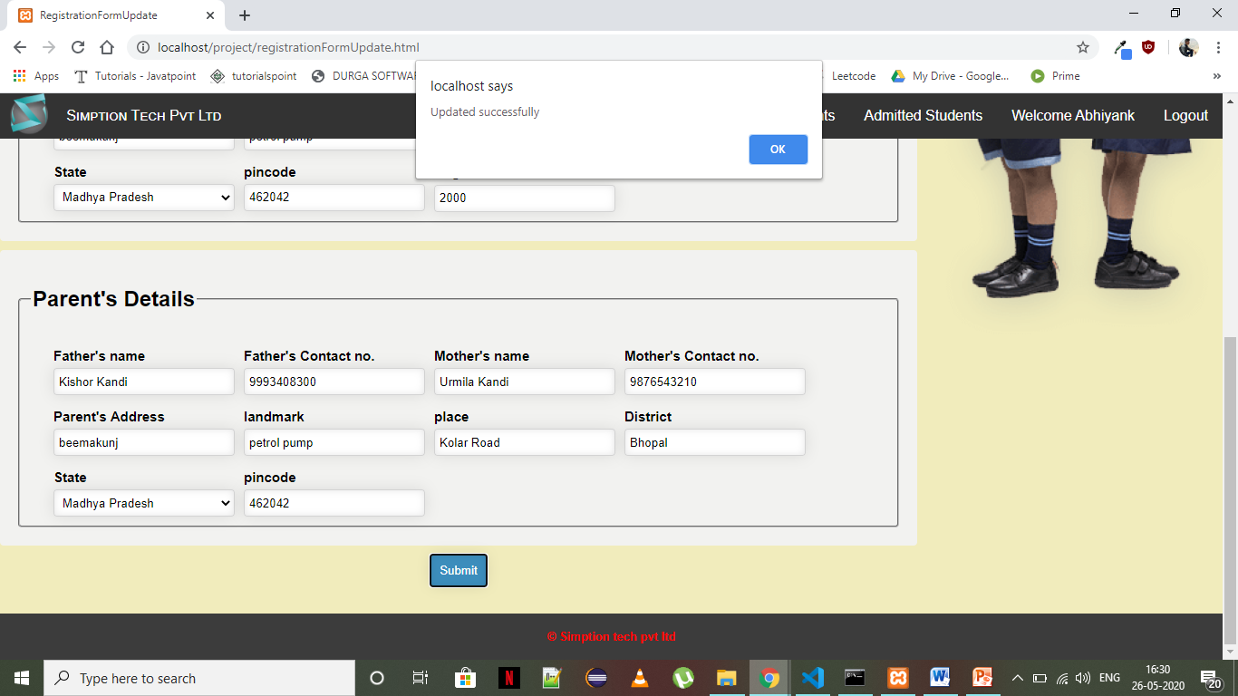

On click of submit button the details which are changed are updated in the database. And the admin is directed to the registered students list page.

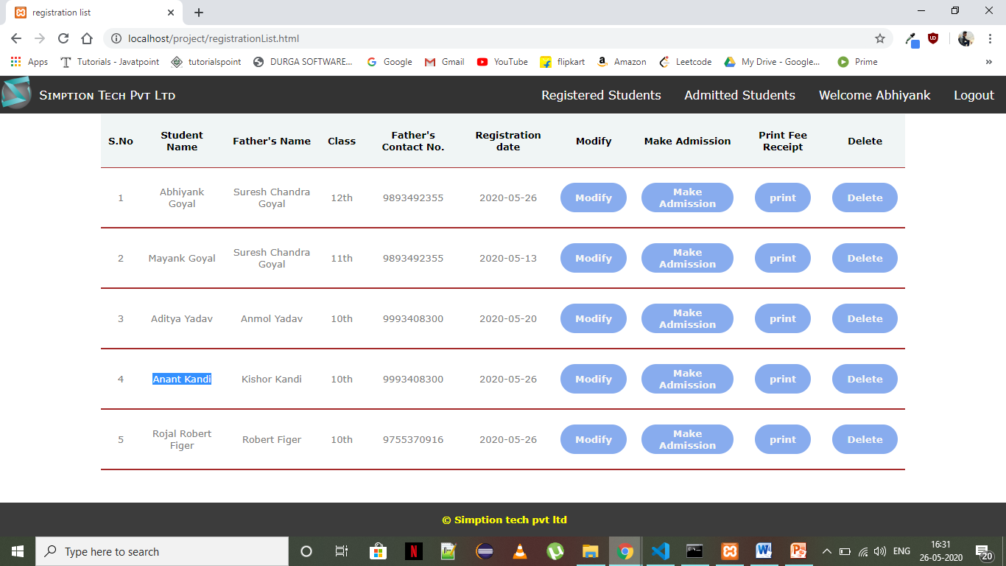

Here the updated details are shown of the student with the other students.

16

**5. Page to Make admission and upload Documuments**

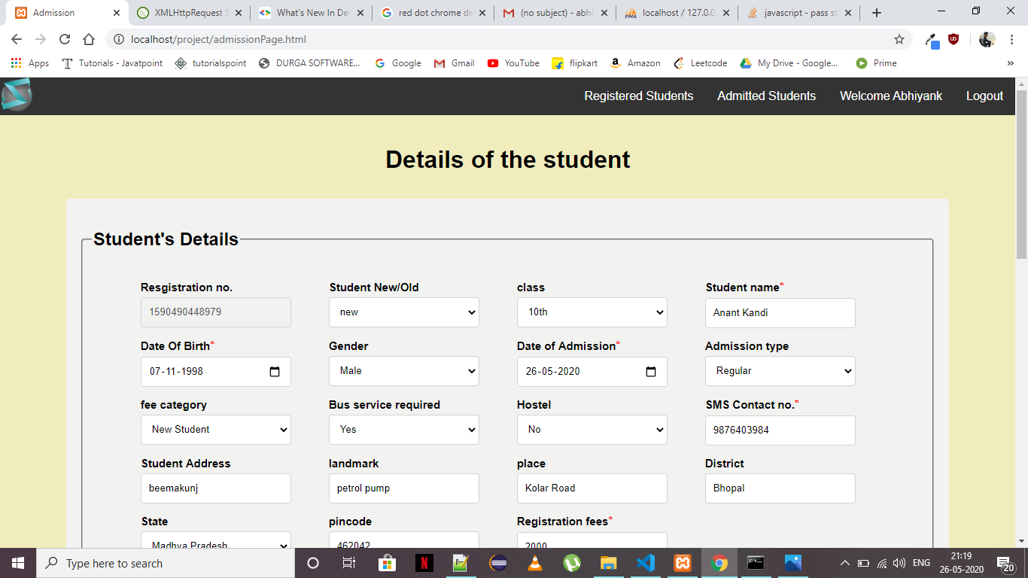 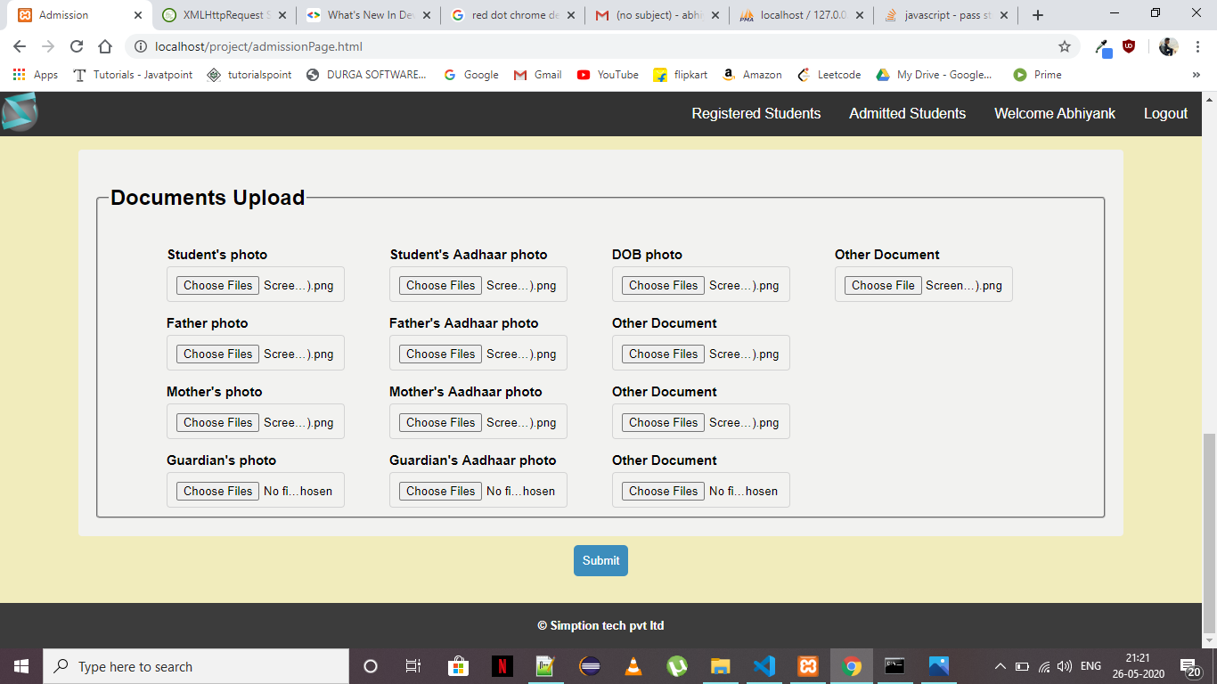

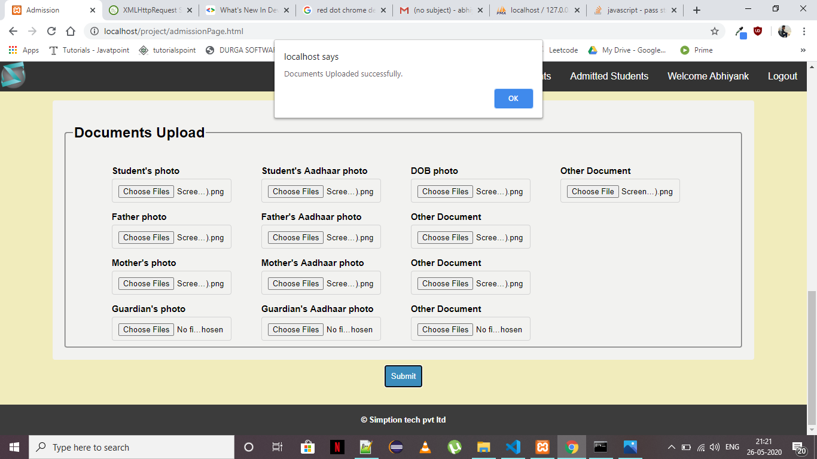

On click of the make admission button the admin will be directed to a new page where the student details will be displayed (fetched from the database) and documents can be uploaded as required for the admission. Also here the admin can also modify the student details. On click of submit button the documents will be uploaded to the separate folder where all the documents of that student will be stored in the student’s registration number folder.

17

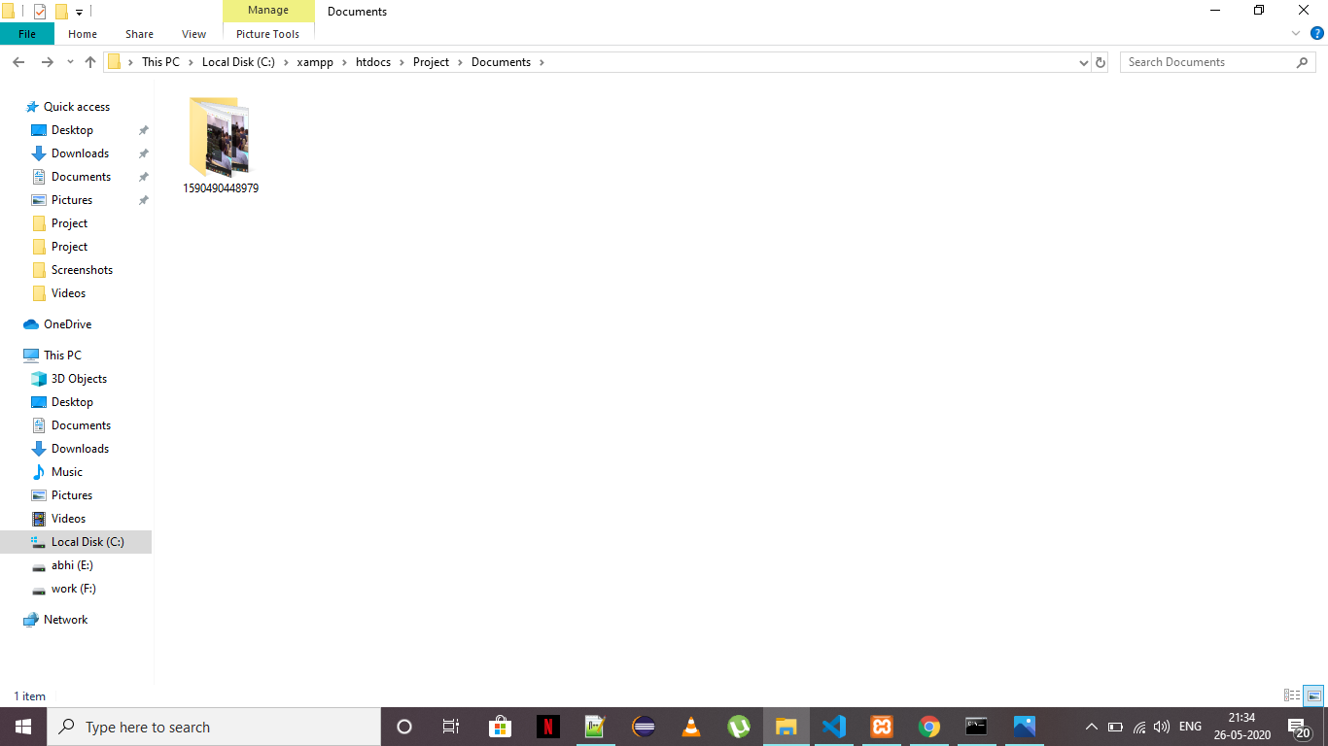

**Figure (a)**

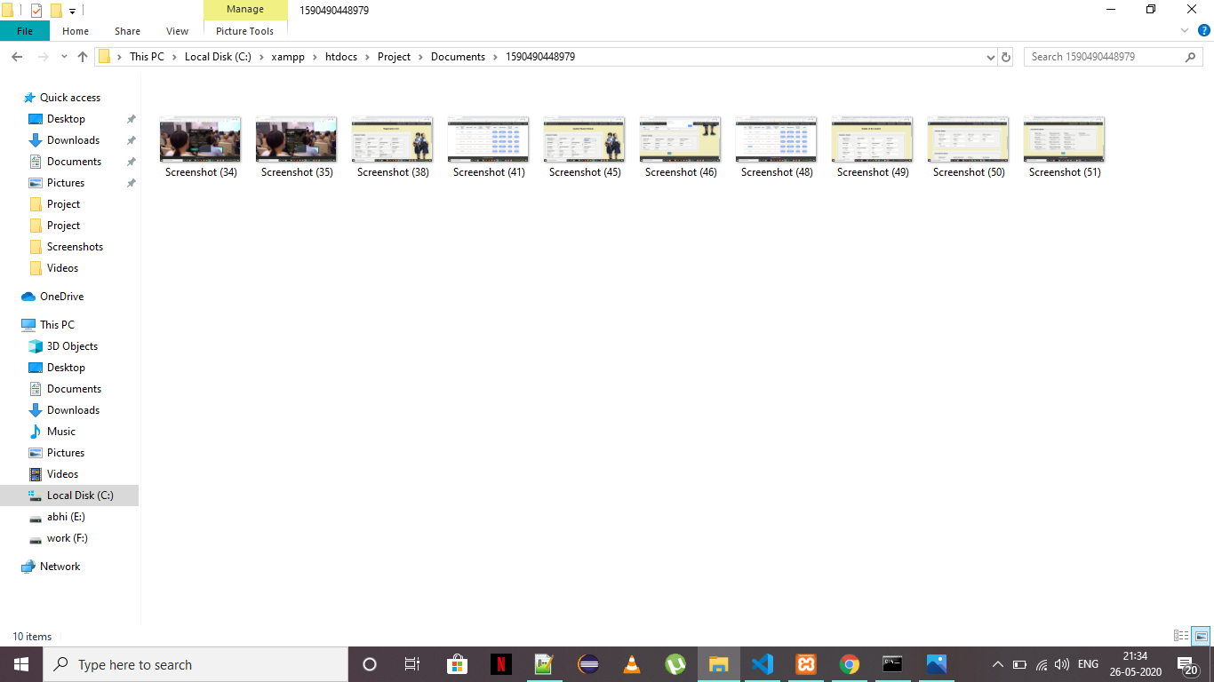

**Figure (b)**

The folder is created with the registration no. of the student as can be seen in the figure (a)

And all the documents are stored in that folder as can be seen in figure (b).

18

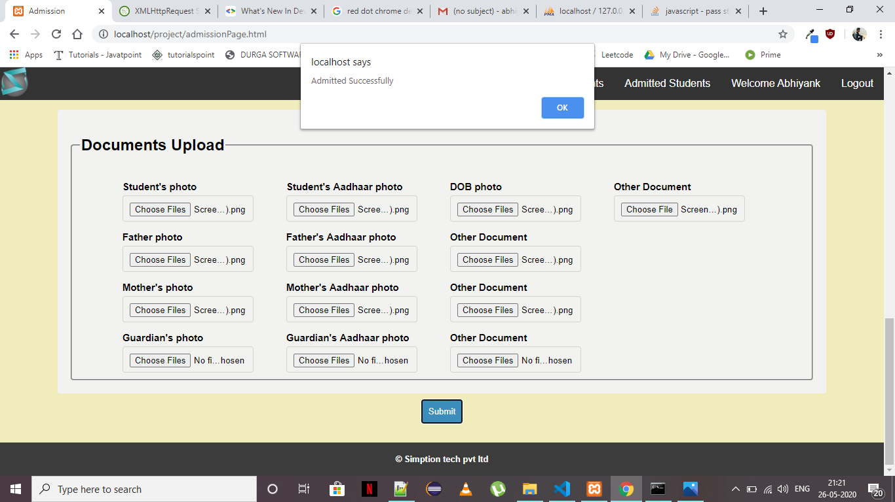

After the successful upload of documents the student’s admission will be done successfully.

**6. Admitted Students Page**

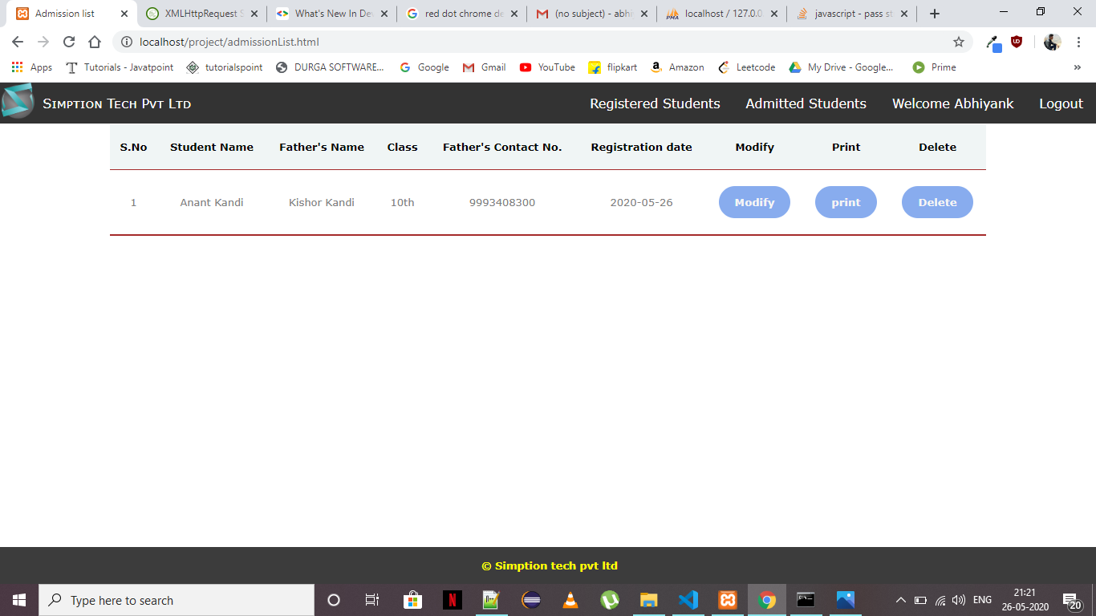

Here the admin can see the list of students already admitted and can modify the details or delete the record of the student. Also he has the option to print the admission fee receipt.

19

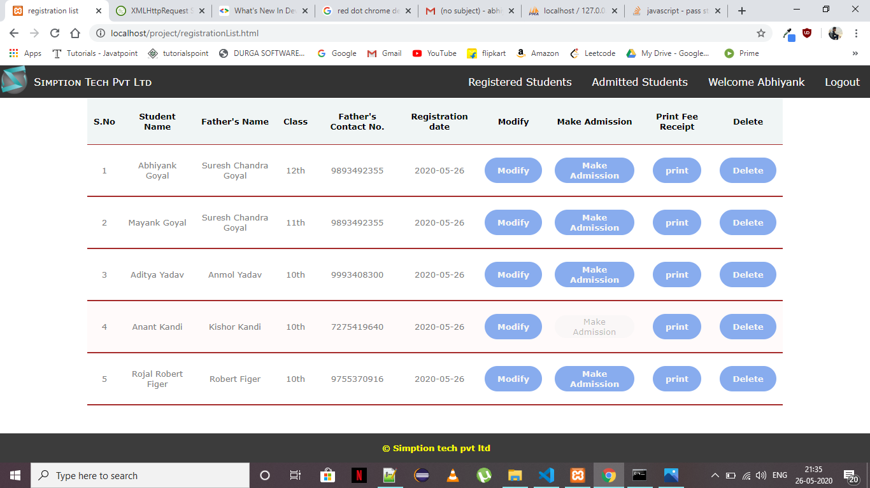

Now once the admission of the student is done successfully the make admission button in the registered students list for that student will be disabled.

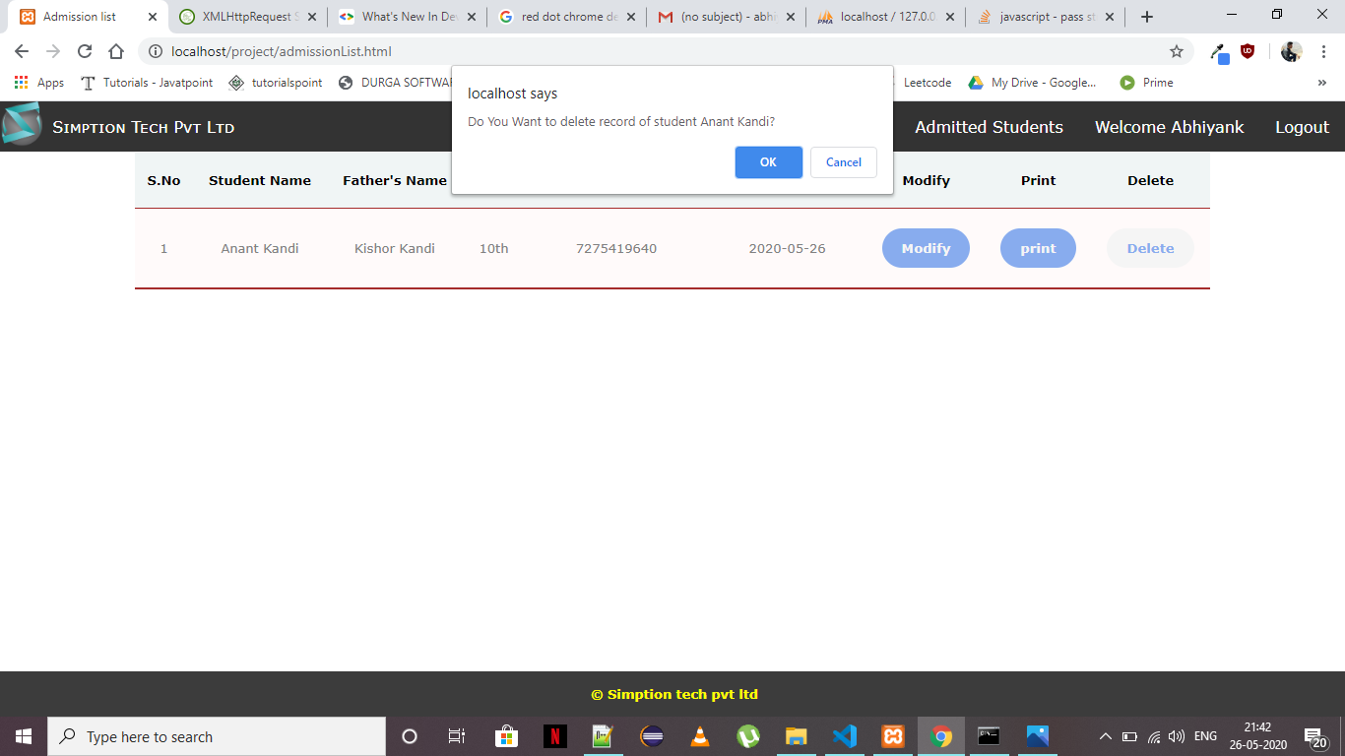

On click of the delete button the admin is asked to confirm his action to delete the student record.

20

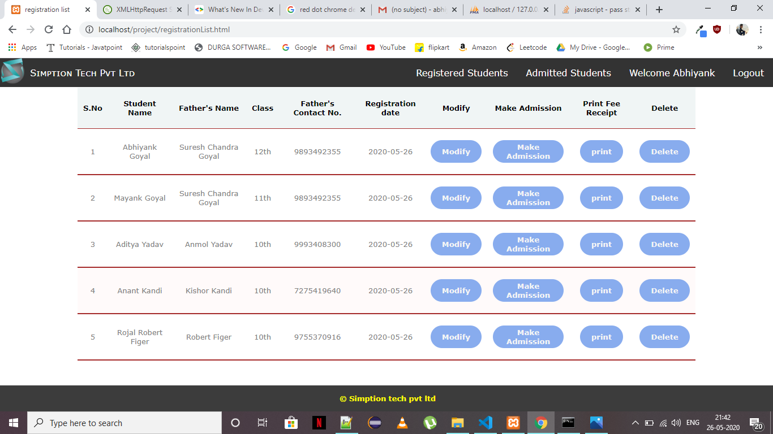

On click of confirm ok the student is deleted from the list of admitted student Page. And the disabled button of make admission becomes enabled as his/her admission can be done again.

* **Result of the Analysis**

Upon entering the valid details of the student, he is successfully registered in the database and on documents upload, the documents are successfully uploaded to the separate directory and on making admission the student is successfully admitted in the database. Modification in the details of the student is working properly. All the functionalities like delete, session login, session logout, delete record are working properly.

21

**Chapter 5: Interpretation**

Based on the results collected and the analysis of those results from the study, it can be deduced that, the introduction of an online registration system will go a long way in improving efficiency of the university as a whole because a greater number of the respondents supported the idea of having registration being done online.

Online registration does not only help the students in reducing the cost on their side but also helps the university authorities in improving their operations in terms of having up to date records where customized reports can be generated. In as much as this would bring about a positive change to the institution and would save a lot of resources.

There are also challenges that come with having registration done online since security issues would become a priority. The development of such a system is a step further in regard of some functionalities added to the system. There is also need to integrate to the various banks which students use for payment of their fees so that third parties are eliminated in the verification of the financial transactions of the students.

22

**Chapter 6: Conclusions and Recommendations**

* **Conclusions**

Successfully used HTML5, CSS, JavaScript, AJAX, PHP, and MySQL to store the information of the student in the database. Learnt the use of different tools and technologies to resolve the real world problems.

* Used HTML5 to design the content the content of the web pages
* Used CSS to style the pages and make the pages responsive.
* Used JavaScript to set the behaviour of the application.
* Used AJAX to exchange the data from the php and the database.
* Used PHP to insert data into the database and perform operations on the data
* Used MySQL to create database to store data and perform various operations on it.
* **Recommendations**:
* Password can be encrypted before persisting in the database. We can use a secret key to encrypt password before storing in the database and same secret key can be used to decrypt the password again while retrieving it from database.
* Application can also incorporate multifactor authentication by sending OTP to mobile number or email address registered before logging in any user.

23

**Chapter 7: Suggestions for future Work**

The student registration system is the next generation address book which will provide these two basic services like portability and security.

The future scope includes expanding the technologies like html, CSS, JavaScript and php and MySQL to add more functionality to the application like adding student enable application where student can directly login to the application and register himself which will reduce the work of administrator. Also there will be less chance of mistakes in the record as the details will be entered by the student himself.

The security can be increased of the application so that no third party can hack the data of the students and make any changes to it.

Various applications can be created to ease the work of students and schools/colleges by expanding the use of the above technologies. Applications like ERP can be created where various actions can be performed like student profile can be displayed, attendance of the student can be updated regularly, results can be send on the application rather than handing it over to the student in paper, fee payment can be done online which will reduce the headache of the administrator and the student to stand in the long queue. The application can be made more robust.

The project will be useful for any schools/ colleges with slight modifications. Project is flexible i.e. any changes or modification in the database can be performed easily. Also this project can be made web enabled. The project will reduce the work headache of the schools/colleges to maintain the record of each student separately in a file. Therefore this project will reduce the paper work for any educational organization.

This project will enhance the working of the schools/colleges and speed up the admission process of the student.

24

**Bibliography**

* <https://www.w3schools.com/html/default.asp>
* <https://www.w3schools.com/css/default.asp>
* <https://www.w3schools.com/js/default.asp>
* <https://www.tutorialspoint.com/javascript/index.htm>
* <https://www.w3schools.com/php/default.asp>
* <https://www.tutorialspoint.com/php/index.htm>
* <https://www.w3schools.com/sql/default.asp>
* <https://www.wikipedia.org/>

25